Smart Care AI personalized Health Assistant


Final Year Project Report Submitted By:
Talha Waheed (023-22-0317)
Abdul Qadeer(023-22-0315)
Adnan Ali(023-22-03)

Supervisor:
Mr. Noor Nabi

In Partial Fulfillment of the Requirements
for the Degree Bachelor of Science (CS)

DEPARTMENT OF COMPUTER SCIENCE SUKKUR IBA UNIVERSITY
KANDHKOT CAMPUS

Smart Care AI personalized Health Assistant
By:
Talha Waheed ,Abdul Qadeer and Adnan Ali
SUBMITTED TO THE COMPUTER SCIENCE DEPARTMENT IN PARTIAL FULFILLMENT OF THE REQUIREMENTS FOR THE DEGREE OF
BACHELOR OF SCIENCE IN COMPUTERR
SCIENCE / SOFTWARE ENGINEERING
At The
SUKKUR IBA UNIVERSITY
June 2026 ©2026< Talha Waheed Abdul Qadeer Adnan Ali
>All Rights reserved.

Signature of Author Talha Waheed Abdul Qadeer Adnan Ali

Certified by: Mr. Faiz Lakhani & Mr. Noor Nabi
Internal Examiner Signature

External Examiner Signature Dr.

Accepted by: Head of Department of Computer Science SIBAU-KANDHKOT Campus

DEPARTMENT OF COMPUTER SCIENCE



CERTIFICATE
By signing below, we attest that the project work "MeshTalk App" that we submitted to the Sukkur IBA University is a record of the original work that we undertook under the guidance of Mr. Faiz Lakhani, lecturer Sukkur IBA University Sindh Pakistan, The project work that is submitted here partially satisfies the requirements for the Bachelor of Computer Science degree. The findings presented in this study have not been distributed to any other universities or institutes to confer degrees or diplomas.

Supervisor
Mr. Noor Nabi

Date:
DECLARATION
We hereby declare that this project report entitled “MeshTalk App” submitted to the “Department of Computer Science Sukkur IBA University”, is a record of work done by us under the guidance of Supervisor Mr. Faiz Lakhani, Also, this project work is submitted in partial fulfillment of the requirements for the degree of Bachelor of Computer Science.

Supervisor: Signature

Mr. Noor Nabi

Team Members: Signature

Talha Waheed

Abdul Qadeer

Adnan Ali

Date:

DEDICATION
“Don’t complain the darkness, Light a candle”

We dedicate this work to the Vice Chancellor of Sukkur IBA University
who lit the candle of education for millions of people by
establishing this meritorious institute,
Sukkur IBA University.
Our work is dedicated to,

Mr. Nisar Ahmad Siddiqui – A Beacon of Light
Founder - Sukkur IBA University

ACKNOWLEDGEMENTS

Thanks to Sukkur IBA University (SIBAU) which gave us such a wonderful opportunity to pursue
quality education.

Thanks to our parents, teachers and friends who always pray for our success and support us at every stage of life.

Thanks to our project Supervisor Mr. Faiz Lakhani for his continuous support and guidance.

Thanks to every single soul of Sukkur IBA University.
Talha Waheed
Abdul Qadeer
Adnan Ali

List of Figures:

1. USE CASE DIAGRAM 43
2. SEQUENCE DIAGRAM 44
3. USER REGISTER- SEQUENCE DIAGRAM 44
2. USER LOGIN- SEQUENCE DIAGRAM 45
3. SEND MESSAGE ONLINE- SEQUENCE DIAGRAM 46
4. SEND MESSAGE OFFLINE SEQUENCE DIAGRAM 47
5 RECEIVE MESSAGE- SEQUENCE DIAGRAM 48
6. DATA SYNCRONIZATION- SEQUENCE DIAGRAM 49
7. CLASS DIAGRAM 52
8. DATABASE DIAGRAM 53
9 ACTIVITY DIAGRAM 54
10. ENTITY RELATIONSHIP DIAGRAM 55
11. SYSTEM ARCHITECTURE DIAGRAM 57
12. USE CASE DIAGRAM 43
13. SEQUENCE DIAGRAM 44
14. CLASS DIAGRAM 52
15. DATABASE DIAGRAM 53
16. ACTIVITY DIAGRAM 54
17. ENTITY RELATIONSHIP DIAGRAM 55
18. SYSTEM ARCHITECTURE DIAGRAM 57

Abbreviations and Acronyms:
Abbreviation / Acronym | Full Form | Description / Usage in Project
SRS | Software Requirements Specification | Document describing system requirements of Smart Care
UI | User Interface | Graphical screens used by Patient, Doctor, and Admin
UX | User Experience | Overall experience of users while using SmartCare
API | Application Programming Interface | Used for communication between frontend and backend services
DB | Database | Stores all system data such as users, prescriptions, and records
SQL | Structured Query Language | Used for managing and querying database data
ERD | Entity Relationship Diagram | Diagram showing relationships between database entities
UML | Unified Modeling Language | Used for system modeling (class, sequence, activity diagrams)
SDLC | Software Development Life Cycle | Process used for developing SmartCare system
ML | Machine Learning | Used for future enhancements like prediction-based recommendations
OTP | One-Time Password | Used for secure user authentication (if applicable)
SMS | Short Message Service | Used for notifications and alerts to patients
HTTP | HyperText Transfer Protocol | Protocol used for web communication
HTTPS | HyperText Transfer Protocol Secure | Secure version of HTTP for data protection
IDE | Integrated Development Environment | Tool used for coding (e.g., VS Code)
OS | Operating System | Platform on which SmartCare runs (Android-based system)
GPS | Global Positioning System | Used for location-based features (if included)
FYP | Final Year Project | Academic project submitted for degree completion
JSON | JavaScript Object Notation | Data format used for API communication
CRUD | Create, Read, Update, Delete | Basic database operations used in system modules

Abstract
Healthcare management has become increasingly important in modern society, where patients often face difficulties in maintaining medication schedules, organizing medical records, and receiving timely health guidance. Traditional healthcare systems frequently rely on manual processes, resulting in poor record management, missed medications, and limited communication between patients and healthcare providers. These challenges can negatively affect treatment outcomes and overall patient well-being.
To address these issues, this project presents Smart Care, an AI-Powered Personalized Health Assistant developed using Flutter and Firebase technologies. Smart Care is a mobile-based healthcare application designed to assist patients, doctors, and administrators through a secure role-based system. The application enables patients to manage medications, receive automated reminders, store health records digitally, view prescriptions, and obtain AI-generated wellness suggestions. Doctors can monitor patient information, create consultations, and issue digital prescriptions, while administrators manage users and system access.
The system utilizes Firebase Authentication for secure user login, Cloud Fire store for real-time database management, Firebase Storage for health record storage, and Firebase Cloud Messaging for notifications. A rule-based AI module is incorporated to provide personalized wellness recommendations based on user data and medication records. The AI component is designed only to offer general health guidance and does not diagnose diseases or prescribe medications.
The implementation of Smart Care demonstrates how mobile and cloud technologies can improve healthcare accessibility, medication adherence, health record management, and communication between patients and doctors. The proposed system provides a secure, user-friendly, and scalable healthcare solution that contributes to more efficient and organized healthcare management.
Keywords: SmartCare, Healthcare Management, Mobile Application, Flutter, Firebase, Artificial Intelligence, Medication Reminder, Health Records, Role-Based Access Control, Personalized Health Assistant.

Chapter 1: Introduction
The healthcare sector has experienced significant growth with the advancement of information technology, mobile computing, cloud services, and artificial intelligence. These technologies have transformed traditional healthcare practices and enabled the development of digital healthcare systems that improve patient care, accessibility, and communication between healthcare providers and patients [1], [3]. Modern healthcare organizations increasingly rely on digital platforms to manage medical records, monitor patient health, and support clinical decision-making processes [5].
Mobile health (mHealth) applications have become an important component of modern healthcare systems. The widespread use of smartphones has enabled healthcare services to become more accessible, allowing patients to manage their health information anytime and anywhere [13]. These applications help users track medications, monitor health conditions, receive reminders, and communicate with healthcare professionals more effectively [7]. According to the World Health Organization (WHO), digital health technologies have the potential to improve healthcare quality, reduce costs, and increase access to healthcare services worldwide [1].
Despite these technological advancements, many patients continue to face challenges in managing their healthcare activities. Medication non-adherence remains a major healthcare concern, particularly among patients with chronic diseases who require long-term treatment plans [2]. Patients often forget to take medications on time, lose important medical records, and struggle to maintain consistent communication with healthcare providers. Such issues can negatively impact treatment outcomes and overall patient well-being [15].
Healthcare professionals also encounter difficulties in managing patient information efficiently. Traditional paper-based record systems are vulnerable to loss, duplication, and accessibility issues. Electronic Health Record (EHR) systems have been introduced to address these limitations by providing secure and organized storage of patient information [6]. Research indicates that EHR systems contribute to improved patient safety, better information sharing, and enhanced healthcare efficiency [15]. However, many healthcare facilities still lack integrated solutions that combine patient management, medication tracking, consultation management, and personalized health guidance within a single platform.
Cloud computing has emerged as a powerful technology for supporting modern healthcare applications. Cloud-based platforms provide scalable storage, real-time synchronization, secure data access, and improved collaboration among healthcare stakeholders [16]. Technologies such as Firebase offer comprehensive cloud services, including authentication, database management, file storage, and notification systems, which simplify the development of healthcare applications [9], [10], [11].
Artificial Intelligence (AI) is another technology that is transforming healthcare services. AI-powered systems are increasingly used for health monitoring, predictive analytics, personalized recommendations, and clinical decision support [3], [4]. These technologies can analyze large volumes of health-related data and provide useful insights to users. However, AI should be used responsibly in healthcare environments and should support healthcare professionals rather than replace them [4].
To address these challenges, this project proposes SmartCare, an AI-Powered Personalized Health Assistant designed to support healthcare management through a secure mobile application. SmartCare is developed using Flutter and Firebase technologies and provides role-based access for Patients, Doctors, and Administrators. The application allows patients to manage medications, receive reminder notifications, upload health records, and access AI-generated wellness suggestions. Doctors can manage consultations and prescriptions, while administrators oversee user management and system security.
The system incorporates Firebase Authentication for secure user access, Cloud Firestore for real-time data management, Firebase Storage for health record storage, and Firebase Cloud Messaging for notifications [9], [10], [11]. Additionally, a rule-based AI recommendation module is integrated to provide personalized wellness suggestions based on patient information and medication records. The AI module is specifically designed to provide general health guidance and does not perform medical diagnosis or prescribe treatments.
The development of SmartCare demonstrates the practical application of modern mobile, cloud, and artificial intelligence technologies in healthcare management. By integrating multiple healthcare services into a single platform, the system aims to improve medication adherence, enhance healthcare communication, promote better health awareness, and contribute to more efficient healthcare management practices [1], [3], [13].

1.1 Problem Statement
Many patients face difficulties in managing their healthcare activities, such as remembering medication schedules, maintaining medical records, and accessing timely health guidance. Traditional record-keeping methods are often inefficient and prone to loss or mismanagement. Additionally, communication between patients and doctors is usually limited, making it difficult to monitor health progress effectively. Existing healthcare applications often focus on individual features rather than providing a complete solution. Therefore, there is a need for a secure and integrated healthcare system that supports medication management, health record storage, doctor consultations, and personalized wellness guidance. Smart Care is developed to address these challenges through a centralized mobile healthcare platform.

1.2 Project Objectives:
The primary objective of Smart Care is to develop a secure, user-friendly, and intelligent mobile healthcare application that helps patients manage their healthcare activities efficiently while improving communication between patients and healthcare providers. The system aims to utilize modern mobile and cloud technologies to provide a centralized platform for healthcare management.
The specific objectives of the project are:
- To develop a role-based healthcare management system for Patients, Doctors, and Administrators.
- To provide secure user authentication and authorization using Firebase Authentication and Role-Based Access Control (RBAC).
- To enable patients to manage their medications by adding, updating, and monitoring medication schedules.
- To provide automated medication reminder notifications that help users follow prescribed treatments on time.
- To allow patients to upload, store, view, and manage their health records securely in cloud storage.
- To facilitate doctors in maintaining consultation records and monitoring patient health information.
- To enable doctors to create and manage digital prescriptions for patients.
- To implement an AI-powered wellness suggestion module that provides personalized health recommendations based on patient data and medication records.
- To improve communication and information sharing between patients and healthcare professionals through a centralized platform.
- To ensure data security, privacy, and integrity through secure cloud-based services and database security rules.
- To provide real-time data synchronization using Firebase services for improved accessibility and system reliability.
- To develop a scalable healthcare solution that can be enhanced with additional healthcare features in future versions.
Through these objectives, Smart Care aims to improve healthcare management, promote medication adherence, enhance patient awareness, and contribute to better healthcare outcomes using modern information technology.

1.3 Project Scope
Smart Care is designed to provide a comprehensive healthcare management platform for Patients, Doctors, and Administrators. The system allows patients to manage medications, receive reminder notifications, upload and store health records, view prescriptions, and receive AI-based wellness suggestions. Doctors can access patient information, create consultation records, and generate digital prescriptions. Administrators are responsible for managing users, adding doctors, assigning roles, and controlling system access. The application utilizes Flutter and Firebase technologies to provide secure authentication, real-time data synchronization, cloud storage, and notification services. The current scope of the project is limited to healthcare management, medication tracking, health record storage, consultation management, and wellness recommendations. Features such as video consultations, online appointment booking, payment processing, insurance integration, wearable device connectivity, and AI-based disease diagnosis are not included in the current version of the system and may be considered for future development.

1.4 Not in Scope
The current version of Smart Care focuses on healthcare management, medication tracking, health record management, and doctor-patient interactions. The following features are not included in the scope of this project:
- Video or audio consultation between patients and doctors.
- Online appointment booking and scheduling system.
- Payment processing and billing management.
- Health insurance integration.
- Pharmacy and medicine delivery services.
- Integration with wearable devices such as smartwatches and fitness trackers.
- AI-based disease diagnosis or medical decision-making.
- Emergency ambulance services.
- Laboratory test booking and result management.
- Multi-language support and iOS-specific optimization.
These features may be considered for future enhancements of the Smart Care system.

1.5 Project Background
The rapid advancement of information and communication technologies has significantly transformed various sectors, including healthcare. Traditional healthcare systems mainly rely on paper-based records and manual processes, which often lead to inefficiencies such as misplaced documents, delayed access to patient information, and communication gaps between healthcare providers and patients [1], [5]. As the global demand for efficient healthcare services continues to increase, digital healthcare solutions have emerged as an effective way to improve healthcare management and patient care [1].
Mobile health (mHealth) applications have become increasingly popular due to the widespread use of smartphones and internet connectivity. These applications enable users to access healthcare services, monitor their health conditions, manage medications, and communicate with healthcare professionals from anywhere at any time [7], [13]. The integration of cloud computing technologies has further enhanced healthcare applications by providing secure data storage, real-time synchronization, and easy access to health information [16].
One of the major challenges faced by patients, particularly those with chronic illnesses, is medication adherence. Many patients forget to take medications on time, miss scheduled doses, or fail to follow prescribed treatment plans [2]. Additionally, maintaining medical records in physical form can be difficult, resulting in lost documents and incomplete health histories. These issues can negatively affect treatment outcomes and overall patient well-being [15]. On the other hand, healthcare providers often need efficient tools to manage patient consultations, prescriptions, and health records in a structured manner [6].
Electronic Health Record (EHR) systems have been introduced to improve the storage, accessibility, and management of patient information. Research has shown that EHR systems contribute to improved patient safety, reduced medical errors, and better healthcare coordination among healthcare professionals [6], [15]. However, many existing healthcare solutions focus only on specific functionalities and fail to provide a comprehensive healthcare management platform.
Artificial Intelligence (AI) has also gained significant attention in the healthcare sector due to its ability to analyze data and provide intelligent recommendations. AI-powered healthcare applications can assist users by offering personalized wellness suggestions, promoting healthy habits, and supporting preventive healthcare practices [3], [4]. However, AI should be used as a supporting tool rather than a replacement for professional medical advice and diagnosis [4].
To address these challenges, the Smart Care project was developed as an AI-Powered Personalized Health Assistant. Smart Care is a mobile application designed to assist patients, doctors, and administrators through a secure and integrated healthcare platform. The system provides medication management, reminder notifications, digital health record storage, consultation management, prescription handling, and AI-based wellness suggestions. By utilizing modern technologies such as Flutter, Firebase Authentication, Cloud Firestore, Firebase Storage, and Firebase Cloud Messaging, the application ensures secure, reliable, and real-time healthcare management [9], [10], [11], [12].
The development of SmartCare reflects the growing need for intelligent healthcare solutions that improve healthcare accessibility, enhance communication between patients and healthcare providers, promote medication adherence, and support better health management practices. The project aims to contribute to the ongoing digital transformation of healthcare by providing a centralized and user-friendly platform that simplifies healthcare management for all stakeholders [1], [3], [13].

1.6 Target Audience
Smart Care is designed for individuals and organizations involved in healthcare management. The system serves three primary categories of users: Patients, Doctors, and Administrators. Each user group has specific responsibilities and interacts with the system according to their assigned role.

1.6.1 Patients
Patients are the primary users of the system. They use Smart Care to manage their medications, receive reminder notifications, upload and store health records, view prescriptions, and obtain AI-based wellness suggestions. The application helps patients maintain their healthcare activities in an organized and efficient manner.

1.6.2 Doctors
Doctors use the system to monitor patient information, review health records, create consultation notes, and generate digital prescriptions. Smart Care assists doctors in maintaining patient histories and improving communication with patients through a centralized platform.

1.6.3 Administrators
Administrators are responsible for managing the overall system. They can add doctor accounts, manage user roles, activate or deactivate accounts, and ensure that the system operates securely and efficiently. Administrators help maintain proper access control and user management within the application.

1.6.4 Healthcare Institutions
Healthcare clinics, medical centers, and small healthcare organizations can also benefit from SmartCare by utilizing its digital healthcare management features. The system can support healthcare providers in organizing patient information and improving service delivery.
Overall, SmartCare is intended for users who require a secure, accessible, and efficient platform for managing healthcare-related information and activities.

1.7 Operating Environment
The SmartCare system operates in a mobile and cloud-based environment designed to provide secure, reliable, and real-time healthcare management services. The application is developed using Flutter and primarily runs on Android devices with internet connectivity. Firebase services are used as the backend infrastructure to handle authentication, database management, cloud storage, and notifications.

1.7.1Hardware Environment
- Android Smartphone or Tablet
- Minimum 3 GB RAM
- Minimum 100 MB free storage space
- Stable Internet Connection (Wi-Fi or Mobile Data)

1.7.2 Software Environment
- Android Operating System (Version 5.0 Lollipop or above)
- Flutter SDK
- Dart Programming Language
- Firebase Authentication
- Cloud Firestore Database
- Firebase Storage
- Firebase Cloud Messaging (FCM)
- Flutter Local Notifications

1.7.2 Development Environment
- Visual Studio Code (VS Code)
- Android Studio
- Firebase Console
- GitHub Version Control System

1.7.3 Network Environment
The application requires an internet connection for user authentication, cloud data synchronization, health record uploads, prescription management, and AI wellness suggestions. Local notification reminders can continue to function even when the device is temporarily offline.
The operating environment ensures that Smart Care provides a secure, scalable, and user-friendly platform for healthcare management while supporting real-time communication between patients, doctors, and administrators.

1.8 System Constraints
The development and operation of Smart Care is subject to various constraints that limit the system's design, implementation, and functionality. These constraints are categorized into technical, operational, security, medical and legal, resource, design constraints, and assumptions.

1.8.1 Technical Constraints
The application is developed exclusively for Android mobile devices. iOS support is not included in this release.
The system requires a stable internet connection for real-time synchronization, authentication, and cloud storage operations. Offline mode is not supported.
The system is built using Flutter and Firebase technologies. Migration to other frameworks would require complete redevelopment.
The application requires Android 6.0 (API level 23) or higher.
Health records and prescriptions are limited to 10 MB per file due to Firebase Storage constraints.

1.8.2 Operational Constraints
Doctors cannot self-register. Only administrators can create doctor accounts.
No SOS or emergency feature is included.
Medication reminders depend on push notifications.
Only English language is supported.

1.8.3 Security Constraints
No two-factor authentication is implemented.
Sessions expire after 7 days of inactivity.
No CSV/PDF export feature is available.

1.8.4 Medical and Legal Constraints
AI provides wellness suggestions only and does not diagnose diseases.
The system is not a replacement for emergency medical services.
Not HIPAA/GDPR compliant; for academic use only.
Digital prescriptions are informational only.

1.8.5 Resource Constraints
Team consists of three members: Talha Waheed, Abdul Qadeer, Adnan Ali.
Project deadline: June 2026.
Uses Firebase free tier only with storage and usage limits.

1.8.6 Design Constraints
Follows Material Design 3.
Optimized for 720p and 1080p screens. No tablet support.
Fixed blue and white theme.

1.8.7 Assumptions
Users have basic mobile knowledge and internet access.
Doctors and admins are trained.
Patients enter correct data.
Healthcare professionals verify AI suggestions.

1.9 System Overview
Smart Care is an AI-powered personalized health assistant designed to provide centralized healthcare management for patients, doctors, and administrators.

1.9.1 System Architecture Overview
Three-tier architecture: Presentation (Flutter app), Logic layer (business rules, AI, authentication), Data layer (Firebase services).

1.9.2 User Roles and Responsibilities
Patients manage medications, records, and receive suggestions.
Doctors issue prescriptions and review patients.
Administrators manage users and system settings.

1.9.3 Core Functional Modules
Authentication, Patient Dashboard, Medication Management, Health Records, AI Suggestions, Doctor Module, Administration Module.

1.9.4 Workflow Description
Users log in via Firebase Authentication and are redirected based on roles. Patients manage medications, doctors issue prescriptions, admins manage users.

1.9.5 Technology Integration
Flutter, Dart, Firebase Authentication, Firestore, Firebase Storage, FCM, Local Notifications.

1.9.6 Security and Access Control
Role-based access control with Firebase security rules and password protection.

1.9.7 Expected Outcomes
Improved medication adherence, better record management, improved communication, and centralized system control.

1.10 External Interface Requirements
This section defines the external interface requirements of the SmartCare system. External interfaces describe all interactions between the SmartCare application and external systems, users, hardware devices, and communication networks. These interfaces ensure smooth communication between system components and the outside environment.

1.10.1 User Interfaces
The SmartCare system provides a graphical user interface (GUI) for three distinct user roles: Patient, Doctor, and Administrator. Each interface is designed following Material Design 3 guidelines to ensure consistency, usability, and accessibility across all screens.

1.10.2 Patient Interface Requirements
The Patient Interface shall include a login screen with email and password input fields. A registration screen shall allow new users to create accounts securely.
The patient dashboard shall display:
- Medication schedules
- Recent health records
- Wellness suggestions
The medication management module shall allow patients to:
- Add new medications
- Edit existing entries
- Delete medications
Each medication entry shall include:
- Medication name
- Dosage
- Frequency
- Reminder time
The health records section shall support file uploads in PDF, JPG, and PNG formats. The prescriptions screen shall display all prescriptions issued by doctors.
The system shall support push notifications for medication reminders. All interfaces shall maintain a consistent blue and white theme and support responsive layouts for Android screen sizes ranging from 720p to 1080p.

1.10.3 Doctor Interface Requirements
The Doctor Interface shall include a login screen identical to the patient login screen with role-based authentication and redirection.
The doctor dashboard shall display a list of assigned patients. The patient details screen shall provide:
- Medical history
- Medication records
- Uploaded health documents
The consultation module shall allow doctors to enter:
- Diagnosis notes
- Consultation comments
- Follow-up recommendations
The prescription module shall enable doctors to:
- Create prescriptions
- Add medicine name, dosage, duration, and instructions
- Save and instantly share prescriptions with patients

1.10.4 Administrator Interface Requirements
The Administrator Interface shall include secure login with role verification.
The admin dashboard shall display system statistics, including:
- Total users
- Number of doctors
- Number of patients
- Number of administrators
The user management screen shall include:
- Search functionality by name or email
- Filter options (All, Patient, Doctor, Admin)
- User cards displaying name, email, and role
Administrators shall have the ability to:
- Change user roles
- Activate or deactivate accounts
A prominent “Add Doctor” button shall be placed at the bottom-right corner of the user management screen.

1.10.5 General Interface Requirements
- All screens shall load within 3 seconds on a standard 4G connection.
- The system shall provide visual feedback for all user actions.
- Error messages shall be displayed in red text near input fields.
- Success messages shall be displayed in green text.
- The application shall support both portrait and landscape modes.
- Touch targets shall be a minimum size of 48×48 dp for usability.

1.11 Hardware Interfaces

1.11.1 Display Interface
The application shall support device displays with resolutions from 720p to 1080p and screen densities ranging from ldpi to xxhdpi.

1.11.2.Storage Interface
The system shall use device internal storage for temporary caching of user data and notification schedules. Cached data shall not exceed 50MB per user.

1.11.3 Notification Interface
The application shall interact with the device notification system using Flutter Local Notifications to display medication reminders.

1.11.4 Camera Interface
The system shall access the device camera to capture and upload health-related images.

1.11.5 File System Interface
The application shall support file selection from device storage for uploading PDF, JPG, and PNG files.

1.12 Software Interfaces
The SmartCare system shall integrate with the following software services:
- Firebase Authentication: Email/password login, registration, password reset, email verification
- Cloud Firestore: CRUD operations for users, medications, health records, consultations, and prescriptions
- Firebase Storage: Upload and download of medical files with metadata stored in Firestore
- Firebase Cloud Messaging: Push notifications for medication reminders
- Flutter Local Notifications: Scheduling of local reminders
- File Picker: Selection of files from device storage

1.13 Communication Interfaces
All communication within the system shall use HTTPS with TLS 1.2 or higher to ensure data security.
The system shall support:
- REST APIs for Firebase Storage
- Real-time synchronization using Firestore listeners
- Minimum bandwidth requirement of 256 kbps
- Automatic retry mechanism for failed requests

1.14 API Requirements
The system shall provide the following APIs:
- Authentication API: login, register, logout, password reset
- Medication API: create, read, update, delete medication records
- Health Records API: upload, view, and delete medical files
- Prescription API: create and view prescriptions
- Admin API: user management, role updates, account activation/deactivation

Chapter 2: LITERATURE REVIEW
This chapter presents a comprehensive review of existing literature relevant to the SmartCare system. The literature review examines previous research and scholarly work in the domains of mobile health applications, artificial intelligence in healthcare, medication management systems, and role-based access control in healthcare information systems. The purpose of this review is to establish the theoretical foundation of SmartCare, identify gaps in existing research, and justify the need for the proposed system [1].
This chapter is organized into several sections. Section 2.2 explores the evolution of mobile health applications and their impact on healthcare delivery. Section 2.3 examines medication management systems and reminder technologies. Section 2.4 reviews the role of artificial intelligence in healthcare and wellness applications. Section 2.5 discusses health record management systems. Section 2.6 analyzes security and access control mechanisms in healthcare applications. Section 2.7 identifies research gaps, and Section 2.8 provides a summary of the chapter.

2.1 Mobile Health Applications
Mobile health applications (mHealth) refer to healthcare services and information delivered through mobile devices such as smartphones and tablets. These applications have significantly transformed healthcare delivery by enabling remote access to medical services, real-time health monitoring, and improved communication between patients and healthcare providers.
With the rapid increase in smartphone usage, mHealth applications have become an essential part of modern healthcare systems. They support features such as appointment scheduling, telemedicine consultations, fitness tracking, and medication reminders. According to recent studies, mHealth applications improve patient engagement and reduce the burden on healthcare facilities by enabling self-care and remote monitoring [2].
However, many existing mHealth systems are limited in functionality and often focus on isolated features rather than providing a fully integrated healthcare solution. This limitation highlights the need for more comprehensive systems like SmartCare.

2.2 Medication Management Systems
Medication management systems are designed to assist patients in taking their prescribed medications correctly and on time. These systems typically include reminder notifications, dosage tracking, and prescription management features.
Research shows that medication non-adherence is a major issue in healthcare, leading to poor treatment outcomes and increased hospital admissions [3]. Digital medication reminder systems have been developed to address this issue by sending alerts and tracking patient compliance.
Despite these advancements, many existing systems lack integration with health records and do not provide real-time updates to healthcare providers. This creates a gap that SmartCare aims to address by integrating medication management with doctor-patient communication and health record systems.

2.3Artificial Intelligence in Healthcare
Artificial Intelligence (AI) plays an increasingly important role in modern healthcare systems. AI technologies are used for disease prediction, medical image analysis, personalized treatment recommendations, and patient monitoring.
Studies have shown that AI-based systems can improve diagnostic accuracy and assist healthcare professionals in making faster and more informed decisions [4]. Machine learning algorithms are also used to analyze patient data and generate personalized wellness suggestions.
However, most AI-based healthcare solutions operate as standalone systems and are not fully integrated with mobile health platforms. SmartCare aims to bridge this gap by incorporating AI-based recommendations within a mobile health ecosystem.

2.3.1 Health Record Management Systems
Health record management systems, including Electronic Health Records (EHR) and Personal Health Records (PHR), are digital platforms used to store and manage patient medical information.
These systems improve healthcare delivery by enabling quick access to patient history, reducing medical errors, and improving coordination among healthcare providers [5]. Cloud-based health record systems further enhance accessibility by allowing data access from multiple devices.
However, challenges such as data privacy, interoperability, and system complexity still exist. Many systems are not user-friendly for patients and lack integration with mobile applications. SmartCare addresses these issues by providing a simplified and mobile-based health record management system.

2.3.2 Security and Access Control
Security is a critical aspect of healthcare information systems due to the sensitive nature of medical data. Role-Based Access Control (RBAC) is widely used to ensure that users can only access information relevant to their roles.
In healthcare systems, RBAC helps define permissions for patients, doctors, and administrators, ensuring data confidentiality and integrity. Studies suggest that RBAC significantly reduces unauthorized access risks and enhances system security [6].
Despite its advantages, many systems implement RBAC in a limited manner without combining it with modern authentication and encryption techniques. SmartCare integrates RBAC with secure authentication mechanisms such as Firebase Authentication and encrypted communication protocols.

2.3.3 Research Gaps
Based on the literature review, several research gaps have been identified:
- Most existing systems focus on single functionalities rather than integrated healthcare solutions.
- Medication management systems often lack real-time doctor integration.
- AI-based healthcare tools are usually standalone and not embedded in mobile applications.
- Many health record systems have poor usability for non-technical users.
- Security implementations are often basic and do not combine multiple layers of protection.
These gaps highlight the need for a unified system that integrates medication management, health records, AI-based recommendations, and secure role-based access control. The SmartCare system is designed to address these limitations.

Chapter: 3 REQUIREMENT SPECIFICATION

3.1 Introduction
This chapter presents a comprehensive specification of the requirements for the SmartCare system. Requirement specification is a critical phase of the Software Development Life Cycle (SDLC) as it establishes a clear understanding between stakeholders and developers regarding what the system must accomplish. This chapter defines both functional and non-functional requirements, identifies user roles, and describes system behavior through use cases and activity flows.
The requirements presented in this chapter are derived from the problem statement, project objectives, and literature review discussed in the previous chapters. Each requirement is defined in a clear and unambiguous manner to ensure proper implementation during the design and development phases of the SmartCare system. Additionally, requirement validation methods and traceability approaches are included to ensure consistency and completeness throughout the development lifecycle [1].

3.2 User Role Definitions
The SmartCare system is designed to support three primary user roles: Patient, Doctor, and Administrator. Each role has specific responsibilities, permissions, and access levels within the system.

3.2.1 Patient Role
The Patient is the primary user of the SmartCare system. Patients utilize the system to manage personal healthcare activities such as medication tracking, health record management, and viewing prescriptions.
Patients can:
- Register and log in to the system
- Manage medications and schedules
- Upload and view health records
- View prescriptions issued by doctors
- Receive AI-generated wellness suggestions
Patients are restricted from accessing doctor or administrative functionalities [2].

3.2.2 Doctor Role
The Doctor represents a certified healthcare professional who interacts with patients through the SmartCare platform.
Doctors can:
- Log in to the system
- View assigned patients
- Access patient medical history and health records
- Create consultation notes
- Generate digital prescriptions
Doctors are not permitted to modify system configurations or access administrative features [3].

3.2.3 Administrator Role
The Administrator is responsible for system-level management and user administration.
Administrators can:
- Manage all user accounts
- Add new doctor accounts
- Activate or deactivate users
- Change user roles
- Monitor system statistics
Administrators do not have access to medical consultation or prescription creation features [4].

3.3 Functional Requirements
Functional requirements describe the core operations that the SmartCare system must perform. These requirements are categorized into modules for clarity.

3.3.1 Authentication Module
Requirement ID | Description
FR-AUTH-01 | The system shall allow users to register using email and password.
FR-AUTH-02 | The system shall validate email format during registration.
FR-AUTH-03 | The system shall enforce a minimum password length of six characters.
FR-AUTH-04 | The system shall prevent duplicate email registrations.
FR-AUTH-05 | The system shall allow users to log in using valid credentials.
FR-AUTH-06 | The system shall authenticate users using Firebase Authentication.
FR-AUTH-07 | The system shall display error messages for invalid login attempts.
FR-AUTH-08 | The system shall redirect users to role-based dashboards after login.
FR-AUTH-09 | The system shall provide password reset functionality via email.
FR-AUTH-10 | The system shall securely log out users and clear session data.

3.3.2 Patient Module
Requirement ID | Description
FR-PAT-01 | The system shall display patient dashboard with medications, records, and prescriptions.
FR-PAT-02 | The system shall allow patients to add medication details.
FR-PAT-03 | The system shall allow editing of existing medications.
FR-PAT-04 | The system shall allow deletion of medications.
FR-PAT-05 | The system shall store medication data in Cloud Firestore.
FR-PAT-06 | The system shall schedule medication reminders using local notifications.
FR-PAT-07 | The system shall send push notifications for reminders.
FR-PAT-08 | The system shall allow uploading of health records in PDF, JPG, and PNG formats.
FR-PAT-09 | The system shall limit file size to 10MB per upload.
FR-PAT-10 | The system shall store files in Firebase Storage.
FR-PAT-11 | The system shall maintain metadata in Firestore.
FR-PAT-12 | The system shall display uploaded health records.
FR-PAT-13 | The system shall allow patients to view prescriptions.
FR-PAT-14 | The system shall display AI-generated wellness suggestions.

3.3.3 AI Wellness Module
Requirement ID | Description
FR-AI-01 | The system shall analyze medication records to generate wellness suggestions.
FR-AI-02 | The system shall provide adherence improvement tips.
FR-AI-03 | The system shall generate hydration reminders when applicable.
FR-AI-04 | The system shall provide sleep and lifestyle recommendations.
FR-AI-05 | The system shall generate general health awareness tips.
FR-AI-06 | The AI module shall not diagnose diseases or prescribe medication.
FR-AI-07 | The system shall display an AI disclaimer.
FR-AI-08 | The system shall update suggestions based on latest user data.

3.3.4 Doctor Module
Requirement ID | Description
FR-DOC-01 | The system shall display assigned patients to doctors.
FR-DOC-02 | The system shall allow patient search by name or email.
FR-DOC-03 | The system shall display patient medical history.
FR-DOC-04 | The system shall allow creation of consultation notes.
FR-DOC-05 | The system shall allow creation of prescriptions.
FR-DOC-06 | Prescriptions shall include medicine details and instructions.
FR-DOC-07 | The system shall store prescriptions in Firestore.
FR-DOC-08 | The system shall instantly reflect prescriptions to patients.
FR-DOC-09 | The system shall log all doctor actions for auditing.

3.3.5 Admin Module
Requirement ID | Description
FR-ADM-01 | The system shall display user statistics on admin dashboard.
FR-ADM-02 | The system shall allow user search functionality.
FR-ADM-03 | The system shall support role-based filtering.
FR-ADM-04 | The system shall display users in card format.
FR-ADM-05 | The system shall allow adding doctor accounts.
FR-ADM-06 | The system shall allow role changes between patient and doctor.
FR-ADM-07 | The system shall allow activation of user accounts.
FR-ADM-08 | The system shall allow deactivation of user accounts.
FR-ADM-09 | The system shall prevent self-role modification of admin.
FR-ADM-10 | The system shall update changes in real-time database.

3.5.6 Use Cases
<USE CASE: Register Account>
Use Case ID: UC-01
Use Case Name: Register Account
Actor: Patient
Description:
Allows a new user to create a patient account in the smart Care system.
Preconditions:
- User has a valid email address.
- User has an active internet connection.
- User has installed the smart Care application.
Post conditions:
- New patient account is created successfully.
- User information is stored in Firebase Authentication and Fire store.
- User is redirected to the Login screen.
Main Flow (Basic Path):
- User opens the smart Care application.
- User clicks the "Register" option.
- User enters full name.
- User enters email address.
- User enters password.
- User confirms password.
- User clicks the "Register" button.
- System validates the entered information.
- System creates a new account using Firebase Authentication.
- System stores user profile information in Firestore.
- System displays a successful registration message.
- System redirects the user to the Login screen.
Alternative Flows:
- If the email already exists, the system displays "Email already registered".
- If passwords do not match, the system displays "Passwords do not match".
- If the password is less than six characters, the system displays an error message.
Exception Flows:
- If there is no internet connection, the system displays "No internet connection".
- If the server is unavailable, the system displays "Please try again later".
Priority: High

USE CASE 01: Register Account
Actor: Patient
Description: New user creates account
Main Flow: Enter name, email, password → System creates account

USE CASE 02: Login to System
Actor: Patient, Doctor, Admin
Description: User authenticates to access system
Main Flow: Enter email, password → System validates → Redirect to dashboard

USE CASE 03: Forgot Password
Actor: Patient, Doctor, Admin
Description: User resets forgotten password
Main Flow: Enter email → System sends reset link

USE CASE 04: Manage Medications
Actor: Patient
Description: Add, edit, delete medications
Main Flow: Enter medication details → Save to database → Schedule reminder

USE CASE 05: Upload Health Records
Actor: Patient
Description: Upload medical documents
Main Flow: Select file → Upload to storage → Save metadata

USE CASE 06: View Prescriptions
Actor: Patient
Description: View prescriptions from doctors
Main Flow: Navigate to prescriptions screen → View list

USE CASE 07: Receive AI Wellness Suggestions
Actor: Patient
Description: Get personalized health tips
Main Flow: System analyzes medications → Displays suggestions

USE CASE 08: Receive Medication Reminders
Actor: Patient
Description: Get push notifications for medications
Main Flow: Scheduled time → Notification appears → User taps to open

USE CASE 09: View Patient List
Actor: Doctor
Description: See assigned patients
Main Flow: Login → System displays patient list

USE CASE 10: View Patient Details
Actor: Doctor
Description: See complete patient information
Main Flow: Select patient → View medications, records, prescriptions

USE CASE 11: Create Consultation
Actor: Doctor
Description: Add consultation notes for patient
Main Flow: Select patient → Enter notes → Save

USE CASE 12: Create Prescription
Actor: Doctor
Description: Issue digital prescription
Main Flow: Select patient → Enter medicine details → Save

USE CASE 13: View All Users
Actor: Admin
Description: See all registered users
Main Flow: Login → System displays user list

USE CASE 14: Search Users
Actor: Admin
Description: Find specific users
Main Flow: Enter search term → System filters results

USE CASE 15: Filter Users by Role
Actor: Admin
Description: Filter users by role type
Main Flow: Click filter button → System shows filtered list

USE CASE 16: Add Doctor Account
Actor: Admin
Description: Create new doctor account
Main Flow: Click "Add Doctor" → Enter details → Create

USE CASE 17: Change User Role
Actor: Admin
Description: Change user between patient and doctor
Main Flow: Select user → Choose new role → Save

USE CASE 18: Activate User Account
Actor: Admin
Description: Activate deactivated account
Main Flow: Select user → Click Activate → Confirm

USE CASE 19: Deactivate User Account
Actor: Admin
Description: Deactivate active account
Main Flow: Select user → Click Deactivate → Confirm

3.4 Non-Functional Requirements
Non-functional requirements define quality attributes such as performance, security, usability, and reliability [5].

3.4.1 Performance Requirements
- System shall load login screen within 2 seconds.
- Authentication shall complete within 3 seconds.
- Dashboard shall load within 3 seconds.
- File upload (5MB) shall complete within 10 seconds.
- System shall support up to 100 concurrent users.
- Notifications shall trigger within 1 second of schedule.

3.4.2 Security Requirements
- Firebase Authentication shall be used for secure login.
- Role-Based Access Control (RBAC) shall be implemented.
- Firestore security rules shall protect data access.
- All communication shall be encrypted using TLS.
- Passwords shall never be stored in plain text.
- Session timeout shall occur after 7 days of inactivity.
- Cross-role access shall be strictly restricted.

3.4.3 Reliability Requirements
- System uptime shall be 99.5%.
- Failed requests shall retry up to 3 times.
- System shall handle network failures gracefully.
- Input validation shall prevent crashes.
- Error messages shall be user-friendly.

3.4.4 Usability Requirements
- UI shall follow Material Design 3 guidelines.
- Consistent color theme shall be used.
- Touch targets shall be minimum 48×48 dp.
- System shall provide clear feedback for actions.
- Interface shall be simple and beginner-friendly.

3.4.5 Scalability Requirements
- System shall scale from 100 to 1000 users.
- Firebase infrastructure shall support required read/write limits.
- New doctors shall be added without downtime.

3.4.6 Availability Requirements
- System shall operate 24/7 for critical services.
- Medication reminders shall function even in background mode.
- Authentication services shall remain continuously available.

3.5 Use Case Analysis
The SmartCare system includes three primary actors:
- Patient
- Doctor
- Administrator
Each actor interacts with specific system functions based on assigned roles.

3.5.1 Patient Use Cases
- Register account
- Login
- Manage medications
- Receive reminders
- Upload health records
- View prescriptions
- View AI suggestions

3.5.2 Doctor Use Cases
- Login
- View patients
- View patient details
- Create consultations
- Create prescriptions

3.5.3 Administrator Use Cases
- Login
- View users
- Search/filter users
- Add doctor accounts
- Change roles
- Activate/deactivate users

3.6 Activity Diagrams

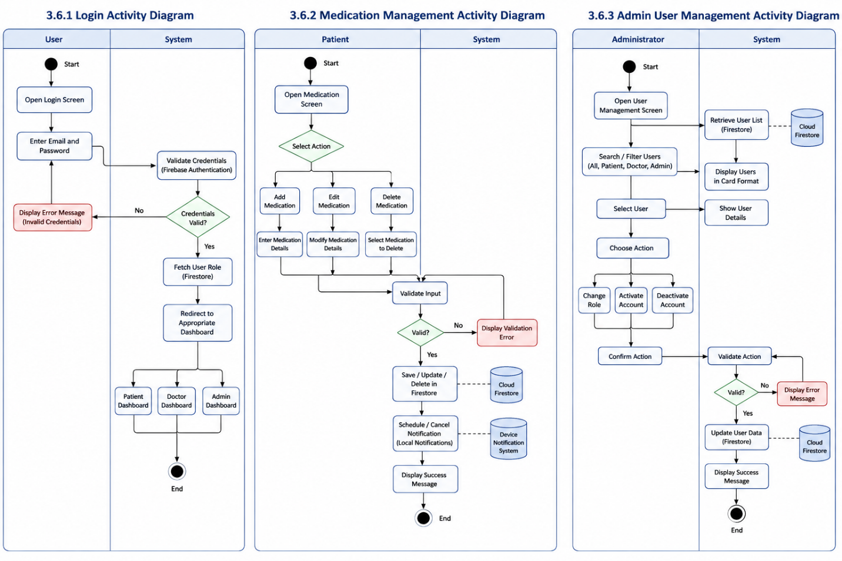

Figure 1.0

3.6.1 Login Activity
User enters credentials → system validates via Firebase → role retrieved → redirected to dashboard → error shown if invalid.

3.6.2 Medication Management
Patient adds/edits/deletes medication → system validates input → stores in Firestore → schedules notification → confirms action.

3.6.3 Admin Management
Admin views users → searches/filter → selects user → updates role/status → database updated → confirmation displayed.

3.7 Requirement Validation
Requirements are validated using the following methods [6]:
- Stakeholder Review: Supervisor feedback incorporated
- Peer Review: Team validation for clarity and completeness
- Prototype Testing: UI/UX tested using early prototype
- Traceability: Each requirement mapped to project objectives

Chapter: 4 PROBLEM DEFINITION

4.1 Problem Description
The healthcare management landscape currently suffers from several critical deficiencies that negatively impact patient outcomes, doctor efficiency, and administrative effectiveness. These challenges form the core problems that the Smart Care system is designed to address.

4.1.1 Medication Non-Adherence
Patients frequently forget to take medications as prescribed. According to the World Health Organization, approximately 50% of patients do not take their medications correctly [1]. This widespread issue leads to worsened health conditions, increased hospitalizations, higher healthcare costs, and in severe cases, preventable deaths. Patients with chronic illnesses or multiple prescriptions face even greater difficulty in maintaining adherence. In the absence of a reliable digital reminder system, patients depend solely on memory, which is often unreliable for long-term medication management.

4.1.2 Disorganized Health Records
Medical records such as prescriptions, laboratory reports, and diagnostic results are often stored in paper-based formats or scattered across multiple locations. This fragmentation creates difficulties in accessing complete medical histories when urgently needed. Paper records are also vulnerable to damage, loss, or deterioration. As a result, patients may undergo repeated tests, leading to unnecessary costs and delayed diagnoses. The lack of a centralized digital repository further limits continuity and efficiency in healthcare delivery.

4.1.3 Limited Doctor–Patient Communication
Communication between patients and doctors is generally restricted to scheduled in-person consultations. Between visits, patients have limited means to share updates, report side effects, or seek medical guidance. Similarly, doctors lack continuous visibility into patient conditions and medication adherence. This communication gap delays timely interventions and reduces the overall continuity of care.

4.1.4 Lack of Personalized Health Guidance
Patients typically receive generalized health advice that is not tailored to their specific conditions, medications, or routines. Such generic recommendations often fail to consider individual health profiles, drug interactions, or lifestyle factors. Consequently, patients miss opportunities for optimized self-care and behavior improvement supported by personalized medical insights.

4.1.5 Inefficient Administrative Management
Healthcare systems without centralized platforms face inefficiencies in managing users, roles, and system access. Tasks such as adding doctors, modifying user roles, activating accounts, or deactivating inactive users require manual effort. As the system scales, these processes become increasingly complex and time-consuming without automation.

Solution Overview
SmartCare is proposed as a comprehensive digital healthcare management system designed to address the above challenges through a centralized, intelligent, and user-friendly mobile platform.

4.2.1 Centralized Healthcare Management Platform
SmartCare integrates all essential healthcare functions into a single application. Patients can manage medications, access health records, and view prescriptions in one place. Doctors can review patient data, issue prescriptions, and maintain consultation records. Administrators manage users and system access through a dedicated interface, eliminating fragmentation across multiple systems.

4.2.2 Intelligent Medication Management with Reminders
The system includes a medication management module that allows patients to add prescriptions with dosage, timing, and frequency details. Automated local and push notifications ensure timely reminders, reducing dependency on memory and improving adherence. Medication schedules are dynamically updated when changes are made.

4.2.3 Digital Health Record Storage
SmartCare provides secure cloud-based storage for medical records. Patients can upload reports in PDF, JPG, or PNG formats. Files are stored using cloud storage, while metadata is managed in a structured database for easy retrieval. This ensures permanent availability, organization, and accessibility of health data.

4.2.4 Enhanced Doctor–Patient Communication
The system enables direct digital communication between doctors and patients through prescriptions and consultation records. Doctors can access patient histories and issue digital prescriptions, which are instantly available to patients, improving response time and continuity of care.

4.2.5 AI-Powered Wellness Suggestions
Smart Care includes an AI-based module that generates personalized wellness recommendations based on patient medication schedules and health data. These suggestions include adherence tips, hydration reminders, sleep guidance, and lifestyle advice. The system does not provide diagnoses or medical prescriptions and includes disclaimers to ensure safe usage.

4.2.6 Role-Based Access Control (RBAC)
The system implements a Role-Based Access Control model with three roles: Patient, Doctor, and Administrator. Each role has defined permissions to ensure security and data integrity. Patients access personal health data, doctors manage consultations, and administrators control system users and roles.

4.2.7 Technical Implementation
SmartCare is developed using Flutter for cross-platform mobile development. Firebase Authentication manages secure login and user sessions, while Cloud Firestore handles database operations. Firebase Storage is used for file management, and Firebase Cloud Messaging combined with local notifications enables medication reminders. This stack ensures scalability, security, and real-time synchronization.

4.2.8 Expected Outcomes
The Smart Care system is expected to achieve the following outcomes:
- Improved medication adherence through automated reminders
- Centralized and secure digital health record management
- Enhanced doctor–patient communication and continuity of care
- Personalized wellness guidance for better lifestyle management
- Efficient and scalable administrative control
- Overall improvement in healthcare accessibility and patient outcomes

Chapter: 5 METHODOLOGY

5.1 Introduction
This chapter describes the methodology adopted for the development of the SmartCare system. A methodology refers to a structured framework that defines the processes, tools, techniques, and practices used to plan, design, implement, test, and deploy a software system [1]. The selection of an appropriate development methodology plays a vital role in ensuring project success, as it directly influences requirement handling, system design, implementation strategy, and quality assurance.
This chapter also outlines the selected software development lifecycle model, tools and technologies used, project management approach, development environment setup, testing strategy, and quality assurance mechanisms applied throughout the development of the SmartCare system [2].

5.2 Software Development Methodology

5.2.1 Selection of Methodology
After evaluating different software development methodologies such as Waterfall, Spiral, and Agile, the Agile methodology was selected for the SmartCare project. Agile was chosen due to the following reasons [3]:
- Requirements for healthcare applications often evolve during development
- The project team consists of three members, making collaboration easier under Agile
- Regular feedback from the supervisor supports iterative improvement
- The six-month project timeline supports sprint-based development
- Agile emphasizes working software over extensive documentation

5.2.2 Agile Principles Applied
The Agile principles applied in the SmartCare development process are summarized below [4]:
Principle | Application in SmartCare
Individuals and interactions | Regular team meetings and supervisor discussions
Working software | Functional prototypes delivered after each sprint
Customer collaboration | Continuous feedback from supervisor and stakeholders
Responding to change | Requirement updates based on feedback
Sustainable development | Balanced sprint planning within academic timeline
Continuous improvement | Sprint retrospectives after each iteration

5.2.3 Sprint Structure
The development process was divided into six sprints, each lasting two weeks:
Sprint | Duration | Focus Area
Sprint 1 | Week 1–2 | Project setup, Firebase configuration, authentication module
Sprint 2 | Week 3–4 | Patient module, medication management, health records
Sprint 3 | Week 5–6 | Notification system and medication reminders
Sprint 4 | Week 7–8 | Doctor module, consultations, prescriptions
Sprint 5 | Week 9–10 | Admin module and AI-based wellness suggestions
Sprint 6 | Week 11–12 | Integration testing, debugging, deployment

5.3 Development Tools and Technologies

5.3.1 Frontend Development
Flutter Framework: Flutter is an open-source UI toolkit developed by Google for building cross-platform mobile applications from a single codebase [5]. It was selected for SmartCare due to its fast development cycle, expressive UI capabilities, and near-native performance. Its hot reload feature significantly improved development efficiency.
Dart Programming Language: Dart is an object-oriented programming language optimized for UI development. It supports both just-in-time (JIT) compilation for development and ahead-of-time (AOT) compilation for production, ensuring both flexibility and performance [5].

5.3.2 Backend Services
- Firebase Authentication: Provides secure user authentication and session management [6]
- Cloud Firestore: A scalable NoSQL database supporting real-time data synchronization [7]
- Firebase Storage: Used for secure storage of medical files and documents [8]
- Firebase Cloud Messaging (FCM): Used for push notifications and medication reminders [9]

5.3.3 Additional Tools
Tool | Purpose
Visual Studio Code | Primary development environment
Android Studio | Emulator and debugging
Git | Version control
GitHub | Source code repository
Postman | API testing
Draw.io | Diagram creation
Microsoft Word | Documentation

5.4 Project Management Approach

5.4.1 Team Roles and Responsibilities
Team Member | Role | Responsibilities
Talha Waheed | Team Lead / Backend Developer | Firebase setup, database design, API integration
Abdul Qadeer | Frontend Developer | Flutter UI development, state management
Adnan Ali | Documentation & Testing | Thesis writing, test cases, quality assurance

5.4.2 Communication Plan
Communication within the project was maintained through:
- Weekly supervisor meetings (Mr. Noor Nabi Dahar)
- Daily team communication via WhatsApp
- Sprint planning sessions at the start of each sprint
- Sprint review meetings at the end of each sprint
- Documentation sharing via Google Drive

5.4.3 Task Management
A Kanban board was used for task tracking:
Column | Description
Backlog | All pending requirements
To Do | Tasks selected for current sprint
In Progress | Tasks under development
Review | Completed tasks under review
Done | Verified and completed tasks

5.5 Development Environment Setup

5.5.1 Software Installation
The following tools were installed on all development machines:
- Flutter SDK (v3.16 or higher)
- Dart SDK (bundled with Flutter)
- Android Studio
- Visual Studio Code
- Git
- Firebase CLI

5.5.2 Firebase Configuration
The Firebase setup process included:
- Creation of a Firebase project named “SmartCare”
- Enabling Email/Password authentication
- Setup of Cloud Firestore database
- Configuration of Firebase Storage security rules
- Enabling Firebase Cloud Messaging
- Registration of Android application package
- Integration of google-services.json file
- Addition of Firebase dependencies in pubspec.yaml

5.5.3 Project Structure
The Flutter project was organized as follows:
smartcare/
├── android/
├── ios/
├── lib/
│ ├── main.dart
│ ├── models/
│ ├── screens/
│ ├── widgets/
│ ├── services/
│ ├── providers/
│ └── utils/
├── assets/
├── test/
└── pubspec.yaml

5.6 Implementation Strategy

5.6.1 Incremental Development
SmartCare was developed using an incremental approach, where new features were added in each sprint while maintaining a working system throughout the development lifecycle [10].

5.6.2 Feature Implementation Order
Features were implemented based on dependency order:
- Authentication module
- Patient module (medications, records)
- Notification system
- Health records module
- Doctor module
- Admin module
- AI wellness module

5.6.3 Code Standards
- camelCase for variables and functions
- PascalCase for classes
- Maximum line length: 80 characters
- Proper inline comments for complex logic
- DartDoc documentation for public APIs

5.7 Testing Strategy

5.7.1 Testing Levels
Level | Description | Tools
Unit Testing | Testing individual functions | Flutter Test
Widget Testing | UI component testing | Flutter Test
Integration Testing | Module interaction testing | Flutter Driver
System Testing | Full system validation | Manual testing
User Acceptance Testing | End-user validation | Beta testing

5.7.2 Test Environment
Testing was performed on:
- Pixel 4 Emulator (Android 12)
- Samsung Galaxy A12 (Android 11)
- Xiaomi Redmi Note 10 (Android 12)

5.7.3 Test Case Structure
Each test case included:
- Test ID
- Description
- Preconditions
- Steps
- Expected Result
- Actual Result
- Status

5.8 Quality Assurance Measures

5.8.1 Code Reviews
All code was reviewed before merging to ensure:
- Correct implementation
- Adherence to standards
- Performance optimization
- Security compliance
- Proper error handling

5.8.2 Continuous Integration
GitHub Actions was used for CI:
- Code push triggers automated tests
- Build generation
- Notification of success/failure

5.8.3 Version Control Strategy
Branch | Purpose
main | Production-ready code
develop | Integration branch
feature/* | Feature development
bugfix/* | Bug fixes
release/* | Release preparation

5.9 Risk Management

5.9.1 Identified Risks
Risk | Probability | Impact | Mitigation
Firebase limit exceeded | Medium | High | Optimize queries
Team absence | Low | Medium | Cross-training
Technical issues | Medium | Medium | Supervisor consultation
Scope creep | High | Medium | Strict requirement control
Delay in submission | Medium | High | Buffer planning

5.9.2 Contingency Plan
- Optimize Firebase usage if limits are reached
- Redistribute tasks during team absence
- Use alternative implementation strategies if needed

5.10 Documentation Approach
- Code Documentation: Dardic comments
- User Documentation: Guides for patients, doctors, admin
- Technical Documentation: API, database schema, deployment guide

Chapter: 6 Use Case Diagram

Use case diagrams are UML diagrams used to represent the functional requirements of a system. They show how different users (actors) interact with the system and the services available to them. Each use case represents a specific task that a user can perform [1].
The Smart Care system consists of three main actors: Patient, Doctor, and Administrator. This section presents the use case diagram and describes the interactions between these actors and the system.

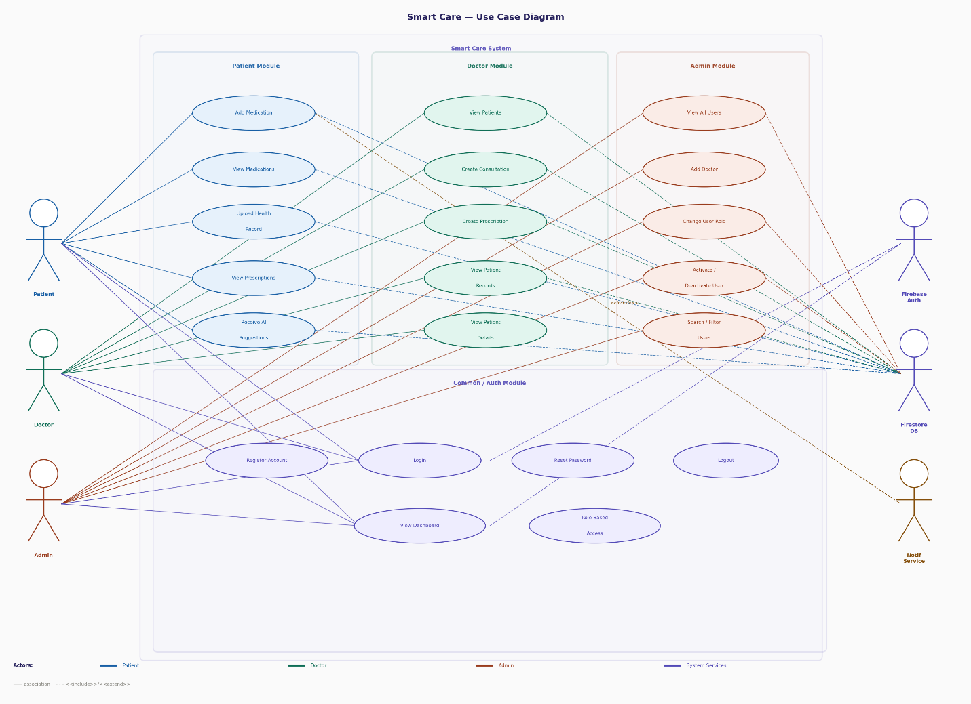
Figure.1: Use Case Diagram

CHAPTER 7: SEQUENCE DIAGRAMS

7.1 Sequence Diagram (SmartCare System)
The SmartCare sequence diagram represents interactions between Patient, Doctor, Admin, and the System during key operations such as login, medication management, consultation, and notification handling.

Diagram
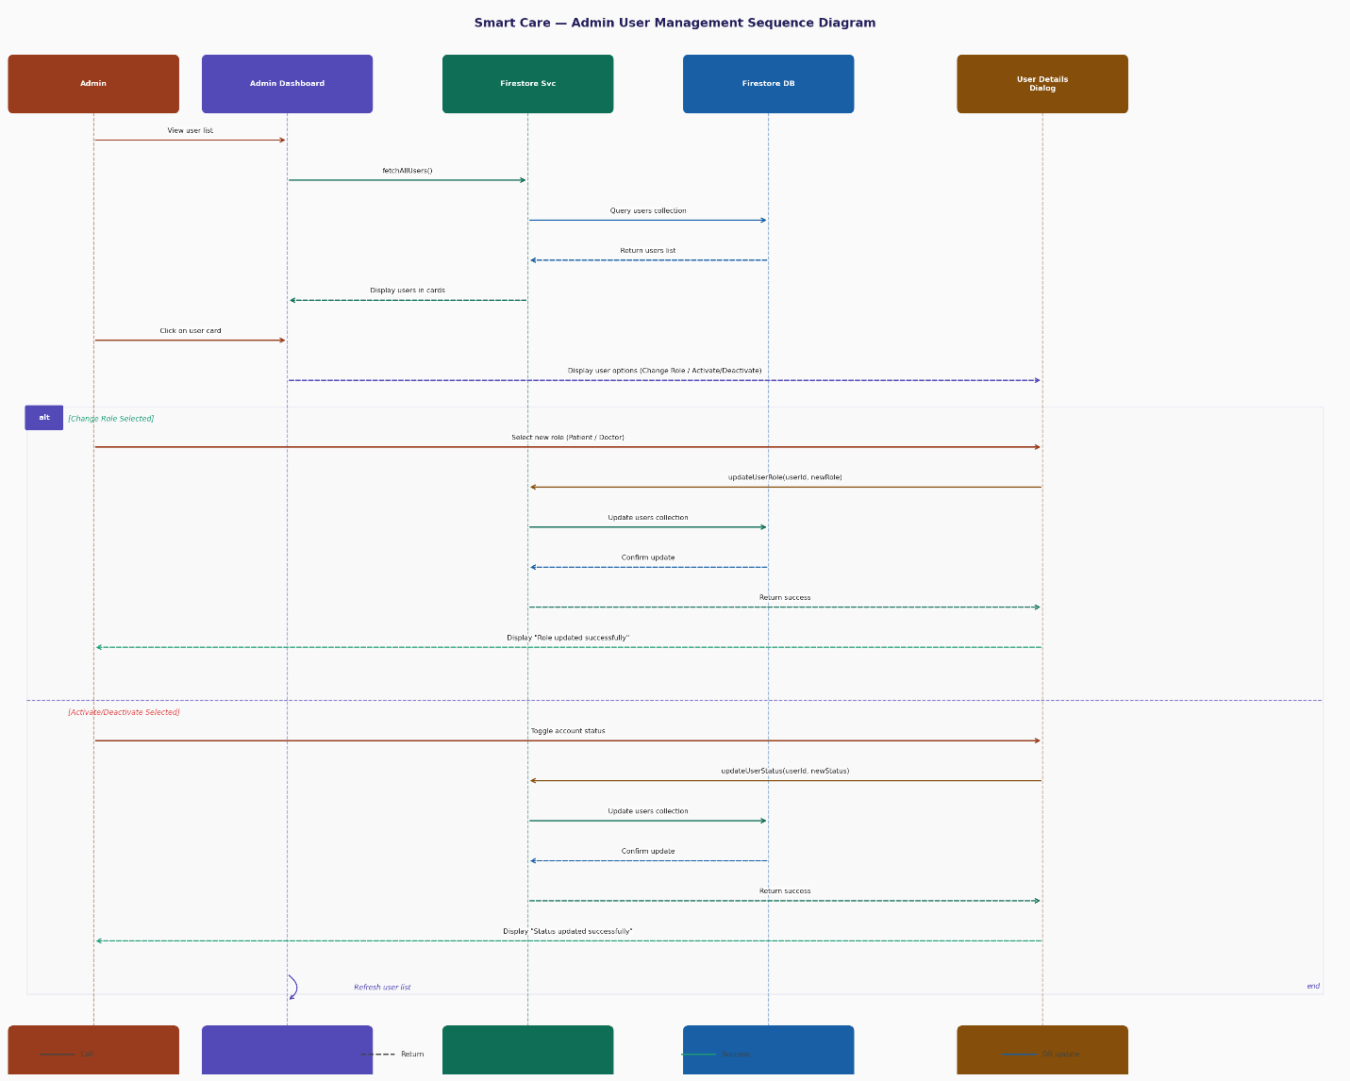
Figure 7.1: SmartCare Sequence Diagram

CHAPTER 8: CLASS DIAGRAM

8.1 Class Diagram (SmartCare System)
The SmartCare system class diagram includes main classes such as User, Patient, Doctor, Admin, Medication, HealthRecord, and Notification. It defines relationships such as inheritance and associations.

Diagram
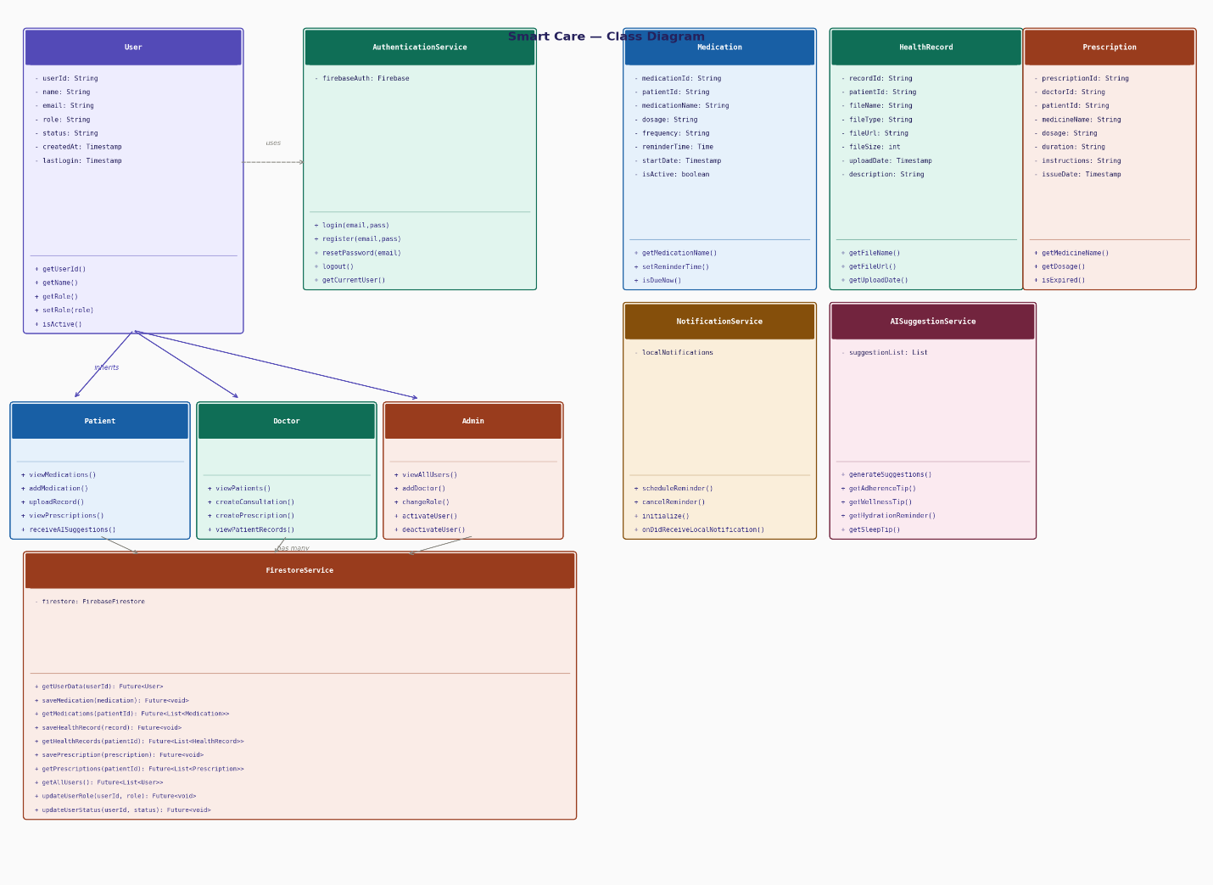
Figure 7.1: SmartCare Class Diagram

CHAPTER 9: DATABASE DESIGN

9.1 Database Design (Firebase)

Collections:
- Users
- Patients
- Doctors
- Medications
- HealthRecords
- Prescriptions
- Notifications
Each collection stores structured JSON-like documents that allow real-time synchronization and scalable storage.

Diagram
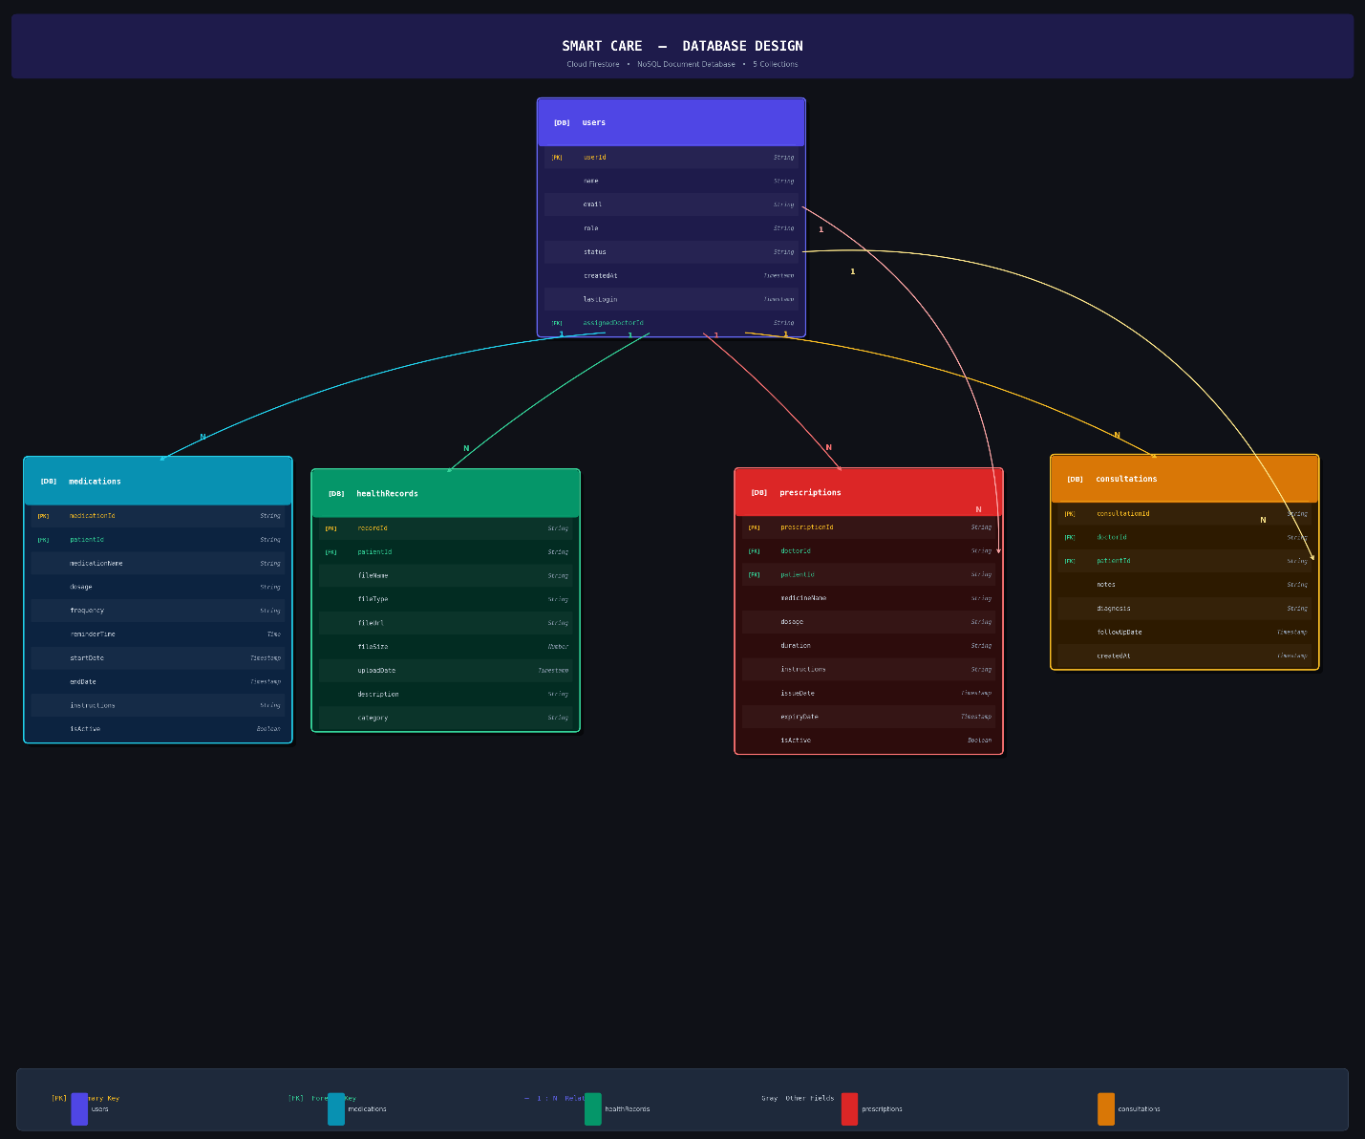
Figure 8.1: Database Schema Diagram

CHAPTER 10: ACTIVITY DIAGRAM

10.1 Activity Diagram (SmartCare System)

Description
The SmartCare activity diagram shows processes such as:
- User login
- Role detection (Patient/Doctor/Admin)
- Feature access
- Medication reminder flow

Diagram
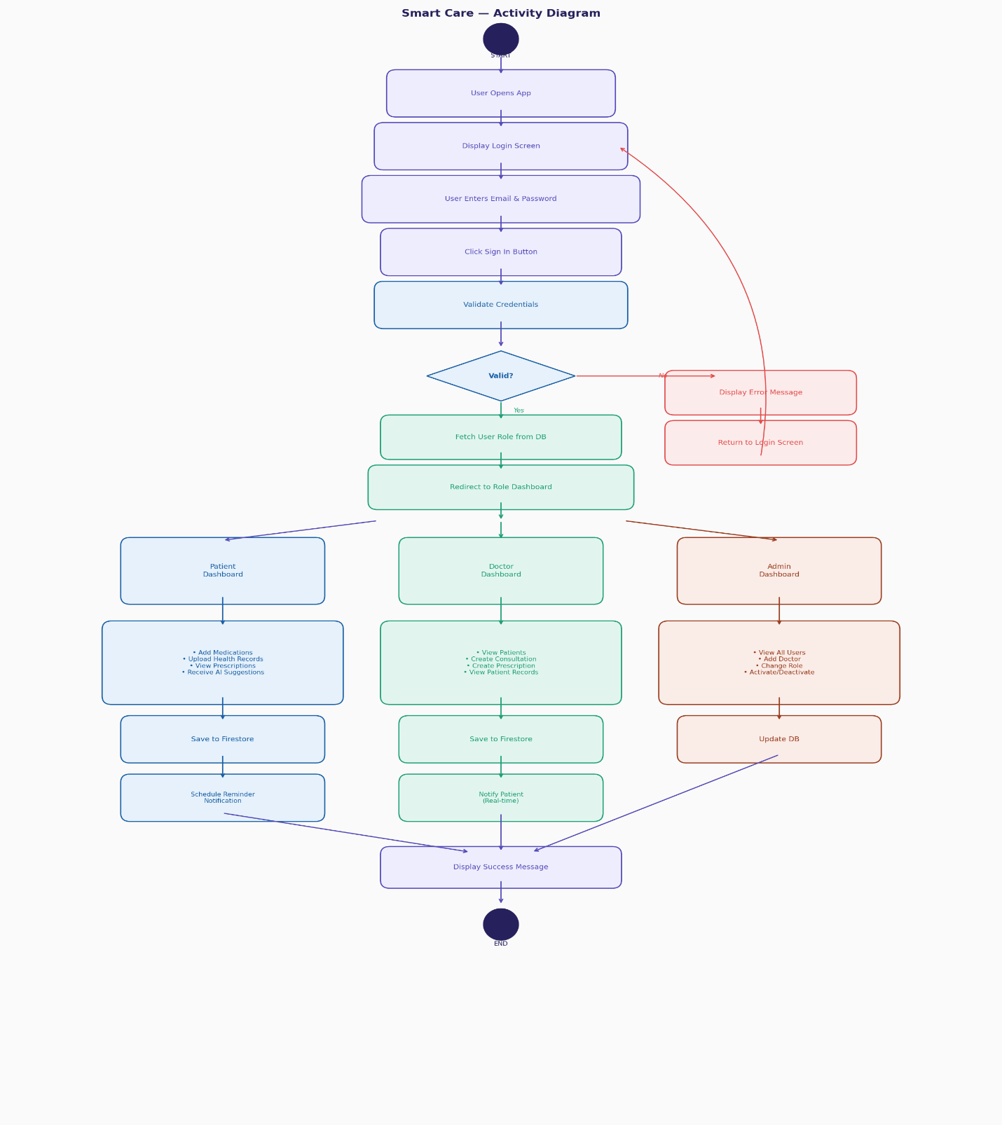
Figure 9.1: SmartCare Activity Diagram

CHAPTER 11: ER DIAGRAM

11.1 ER Diagram (SmartCare System)

Entities:
- User
- Patient
- Doctor
- Medication
- HealthRecord
- Prescription

Relationships:
- Patient has many Medications
- Doctor issues Prescriptions
- User manages Health Records

Diagram
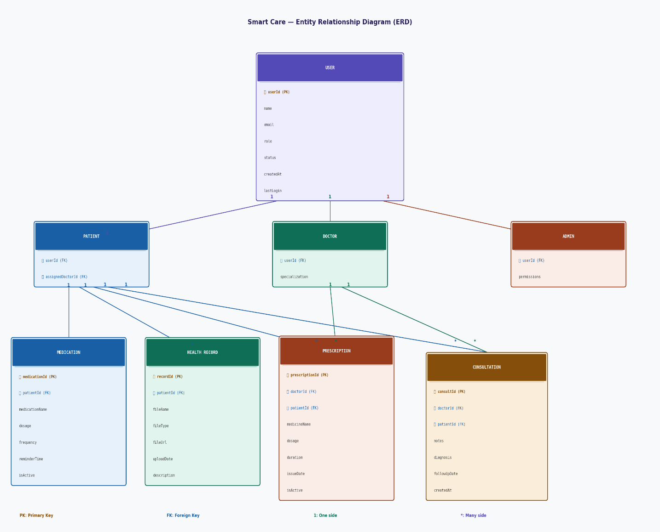
Figure 10.1: SmartCare ER Diagram

CHAPTER 12: SYSTEM ARCHITECTURE

12.2 SmartCare System Architecture

Description
SmartCare follows a layered architecture:
- Presentation Layer: Flutter Mobile App
- Business Logic Layer: Dart Services
- Backend Layer: Firebase Services
- Database Layer: Cloud Firestore
- Storage Layer: Firebase Storage
- Notification Layer: Firebase Cloud Messaging

Diagram
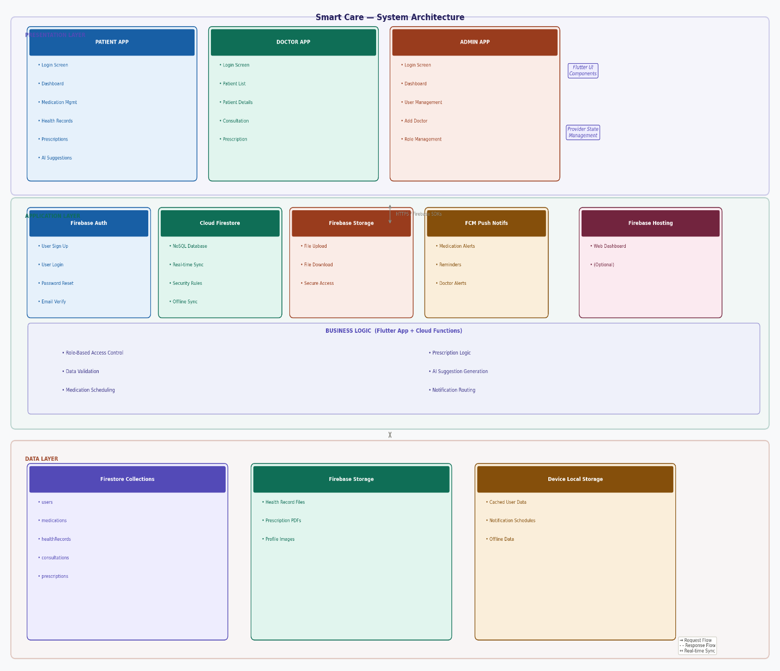
Figure 11.1: System Architecture Diagram

CHAPTER 13: IMPLEMENTATION AND TESTING

13.1 Testing
Testing was performed at multiple levels:
- Unit Testing
- Widget Testing
- Integration Testing
- System Testing
- User Acceptance Testing
Testing ensured that all modules functioned correctly under different scenarios.

13.2 Test Results
All major modules including authentication, medication management, reminders, doctor consultation, and admin control were successfully tested and validated.

7.4 Functional Testing
Functional testing was performed to verify that all modules of the SmartCare system operate according to the specified requirements. The test cases focused on authentication, medication management, health records, AI wellness suggestions, prescription management, and user administration. The results indicate that all tested functionalities performed successfully and met the expected outcomes.

Table 7.1: Functional Testing Results of SmartCare System
Test Case ID | Test Scenario | Preconditions | Test Steps | Expected Result | Status
TC-01 | User Login | User account exists | Open the application, enter valid email and password, and click Login | User successfully logs into the system | Pass
TC-02 | Invalid Login | User account exists | Enter incorrect login credentials and click Login | System displays an error message | Pass
TC-03 | Patient Registration | User is not registered | Open Registration page, enter required information, and click Register | New patient account is created successfully | Pass
TC-04 | Forgot Password | Registered user exists | Select Forgot Password, enter email address, and submit request | Password reset email is sent | Pass
TC-05 | Add Medication | Patient is logged in | Open Medication page, enter medication details, and save | Medication is added successfully | Pass
TC-06 | Edit Medication | Medication record exists | Select medication, update information, and save changes | Medication details are updated successfully | Pass
TC-07 | Delete Medication | Medication record exists | Select medication and click Delete | Medication is removed successfully | Pass
TC-08 | Medication Reminder | Medication reminder is scheduled | Wait until scheduled reminder time | Notification appears on the device | Pass
TC-09 | Mark Medication as Taken | Medication exists | Open medication list and mark medication as taken | Medication log is stored successfully | Pass
TC-10 | Upload Health Record | Patient is logged in | Open Health Records page, select a file, and upload it | File uploads successfully to cloud storage | Pass
TC-11 | View Health Record | Health record exists | Select an uploaded record | Health record opens successfully | Pass
TC-12 | Delete Health Record | Health record exists | Select a health record and delete it | Record is removed successfully | Pass
TC-13 | View AI Suggestions | Patient is logged in | Open AI Suggestions page | Personalized wellness suggestions are displayed | Pass
TC-14 | View Patient List | Doctor is logged in | Open Patient List page | Patient information is displayed successfully | Pass
TC-15 | Add Consultation | Doctor is logged in | Select patient, enter consultation details, and save | Consultation is stored successfully | Pass
TC-16 | Create Prescription | Doctor is logged in | Select patient, enter prescription details, and save | Prescription is created successfully | Pass
TC-17 | View Prescription | Patient has a prescription | Open Prescriptions page | Prescription information is displayed correctly | Pass
TC-18 | Add Doctor | Administrator is logged in | Open Admin Panel, add doctor information, and save | Doctor account is created successfully | Pass
TC-19 | Change User Role | Administrator is logged in | Select user, change role, and save | User role is updated successfully | Pass
TC-20 | Activate/Deactivate User | Administrator is logged in | Select user account and change status | User account status is updated successfully | Pass
TC-21 | Unauthorized Access Check | User is logged in | Attempt to access a restricted module | System denies access and displays an appropriate message | Pass
TC-22 | Logout | User is logged in | Click Logout button | User is redirected to the Login screen | Pass

Table 7.2: Security Testing Results
Test Case ID | Test Scenario | Preconditions | Test Steps | Expected Result | Status
ST-01 | Patient Access Admin Panel | Patient logged in | Try opening Admin module | Access denied | Pass
ST-02 | Patient Create Prescription | Patient logged in | Attempt prescription creation | Operation blocked | Pass
ST-03 | Doctor Access Admin Features | Doctor logged in | Open Admin Panel | Access denied | Pass
ST-04 | Inactive User Login | Account deactivated | Attempt login | Login blocked | Pass
ST-05 | Fire store Role Validation | User authenticated | Attempt unauthorized database action | Request denied by security rules | Pass
Table 7.3: Performance Testing Results
Test Case ID | Test Scenario | Preconditions | Test Steps | Expected Result | Status
PT-01 | Login Response Time | Internet connected | Login to application | Login completed within a few seconds | Pass
PT-02 | Health Record Upload | File available | Upload PDF/Image file | Upload completed successfully | Pass
PT-03 | Data Synchronization | Multiple devices connected | Update data on one device | Changes reflected in real-time | Pass
PT-04 | Notification Delivery | Reminder scheduled | Wait for reminder time | Notification delivered successfully | Pass
Bottom of Form

CHAPTER 14: RESULTS AND DISCUSSION

14.1 Results
The SmartCare system successfully achieved the following outcomes:
- Improved medication adherence through reminders
- Secure and centralized health record storage
- Improved doctor-patient communication
- Automated administrative management
- Personalized AI-based health suggestions

14.2 Discussion
The system demonstrates how mobile and cloud technologies can improve healthcare management. Firebase integration enabled real-time updates, while Flutter ensured smooth cross-platform performance. The system effectively addresses major healthcare inefficiencies identified in the problem statement.

CHAPTER 15: REFERENCES

